Intro
1st TECHNICAL COMMITTEE MEETING
24 – 28 February 2025

JURY PANEL MEETING NOTES

Jury Chairperson: | Pacharasuda Podhiarn
Chief Expert: | Leow Zhen Zhen
Deputy Chief Expert: | Yahya Bin Ibrahim
Workshop Manager: | Jerry O. Taroy

# | Items/Topics | Status | Remarks
1 | Updated the Members Contact List | Completed
1.1 | --| Total number of Participants in the 1st TCM | 12
1.2 | --| Total number of Experts in the 1st TCM | 9
2 | Confirmed total number of Competitors | 12 | Subject for confirmation (Vietnam and Myanmar)
3 | Confirmed review and adherence to the WSASEAN2025 Rules and Procedures | Completed
4 | Reviewed and updated the Technical Description | Completed
4.1 | --| Confirmed Competition Documents to be adopted | Adopted WS Lyon 2024
4.2 | --| Printed and signed all pages of the Technical Description | Completed
5 | Presented the overall layout of the Venue | Completed
6 | Approved the Workshop Area floor plan | Completed
6.1 | Reviewed the common furnitures and equipment to be provided by the host | Completed
7 | Completed the Infrastructure List | Completed
8 | Developed the Test Project | On-going | Each expert will bring the Test Project on the 2nd TCM
8.1 | --| Completed Modules, Duration and Weights for the skill area | Completed
8.2 | --| Completed Competition Timetable | Completed
9 | Developed the Standards and Assessment Guidelines | Completed
10 | Developed the Marking Scheme | On-going | To be completed during the 2nd TCM
10.1 | --| Is Dual Marking Allowed? | N/A
10.2 | --| Imported the Marking Scheme to CIS | On-going | To be completed during the 2nd TCM
11 | Discussed the Health, Safety & Environment | Completed
12 | Any Other Business
13 | Signed the final Agreement Form

Group Photo

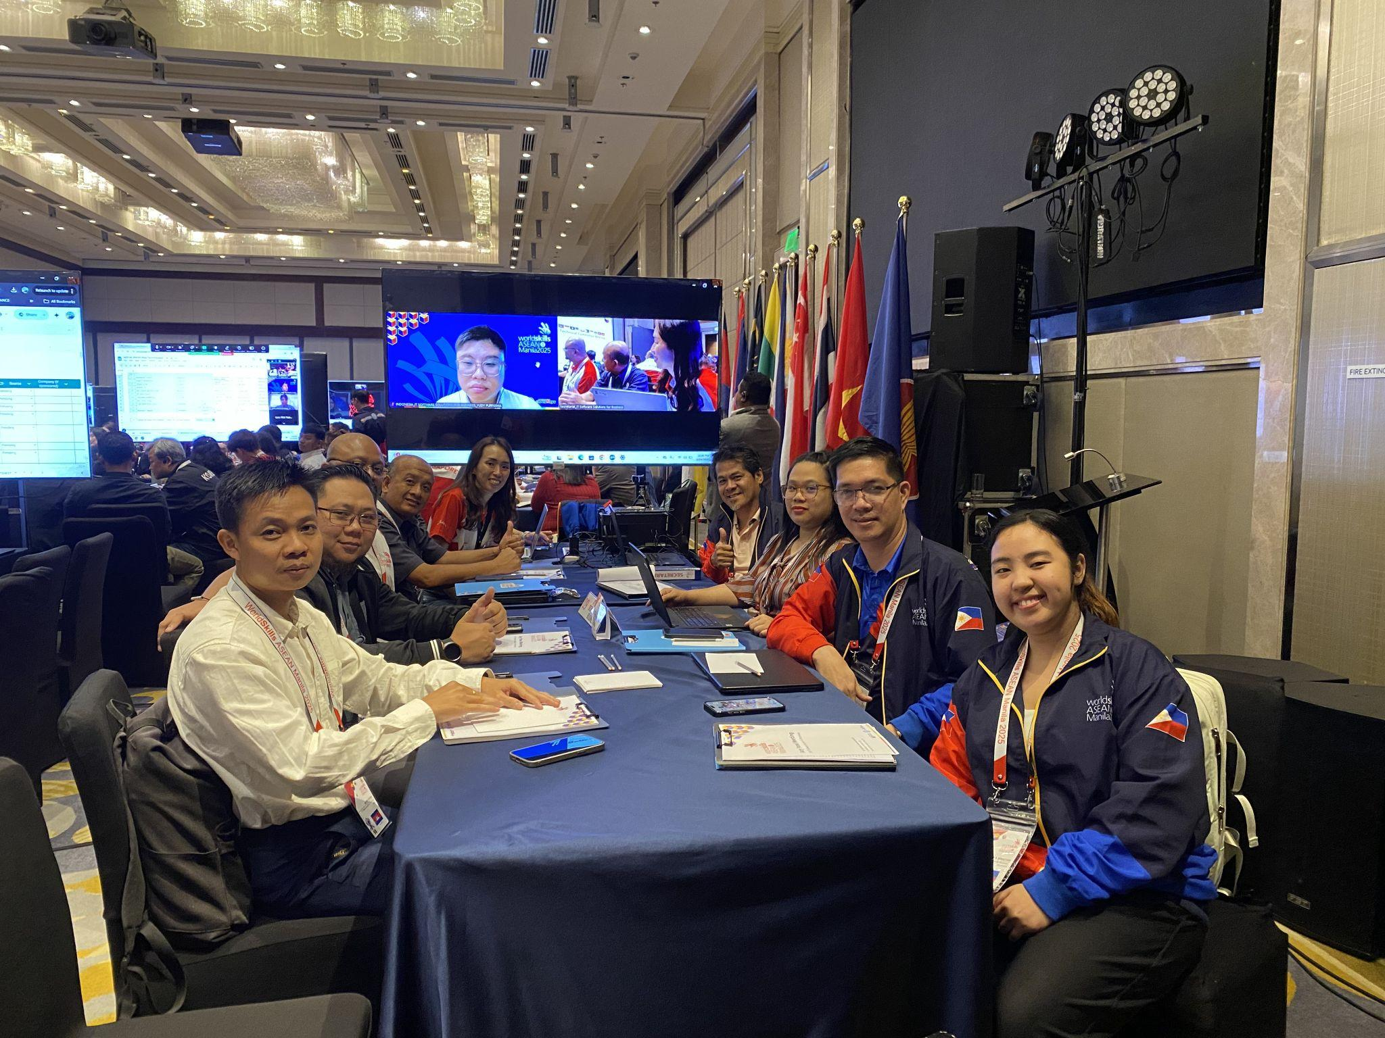  Day 1 - February 25, 2025 | 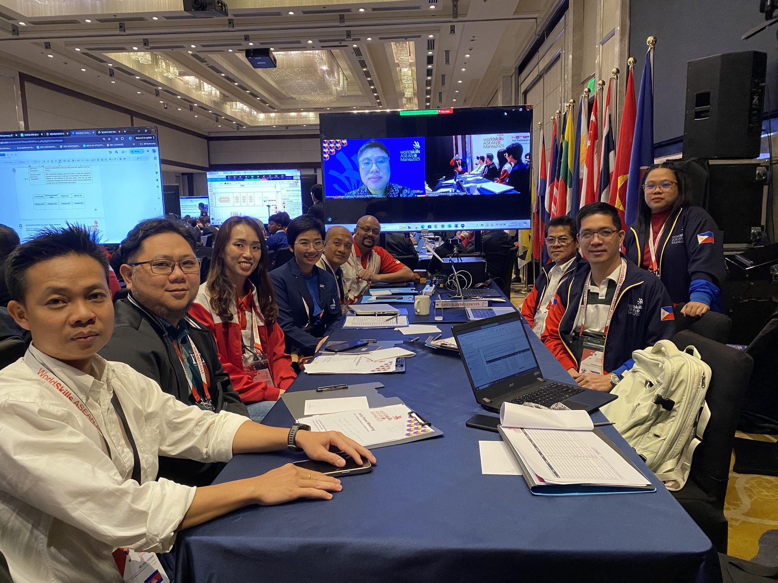  Day 2 - February 26, 2025
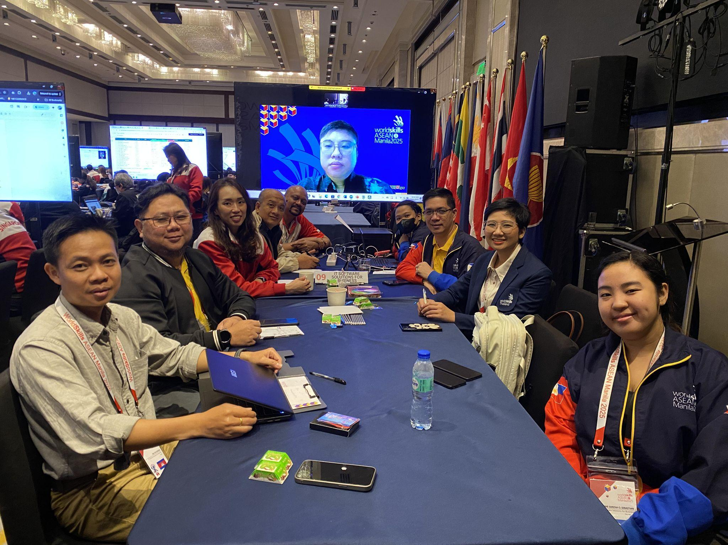  Day 3 - February 27, 2025 | 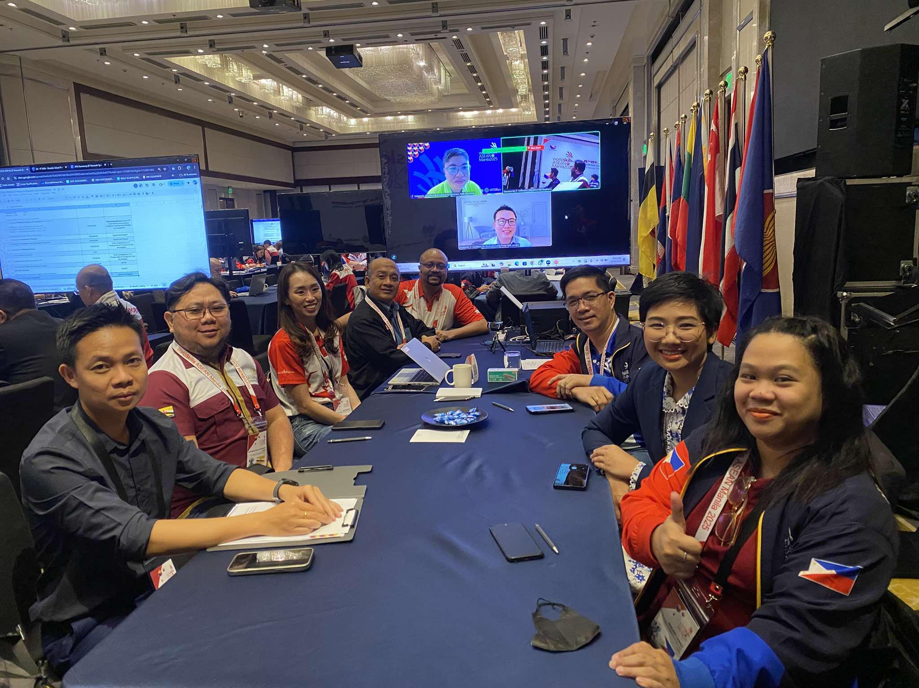  Day 4 - February 28, 2025

Annex A. Attendance

No. | Name | Country | Position | Day 1 | Day 2 | Day 3 | Day 4
1 | Pacharasuda Podhiarn | Thailand | JC | ✅ | ✅ | ✅ | ✅
2 | Leow Zhen Zhen | Singapore | CE | ✅ | ✅ | ✅ | ✅
3 | Yahya Bin Ibrahim | Malaysia | DCE | ✅ | ✅ | ✅ | ✅
4 | Mohammad Rizal bin Haji Mohd. Hendry | Brunei Darussalam | E | ✅ | ✅ | ✅ | ✅
5 | Hou Keanan | Cambodia | E | ✅ | ✅ | ✅ | ✅
6 | Yudy Purnama | Indonesia | E | ✅ | ✅ | ✅ | ✅
7 | Edwardo G. Reyes | Philippines | E | ✅ | ✅ | ✅ | ✅
8 | Mary Jane F. Somao-i | Philippines | E | ✅ | ✅ | ✅ | ✅
9 | Sathish s/o Sritharan | Singapore | E | ✅ | ✅ | ✅ | ✅
10 |  | Vietnam | E
11 | Aung Pyae Hein | Myanmar | E |  |  |  | ✅
12 | Jerry O. Taroy | Philippines | WM | ✅ | ✅
13 | Neome Sarena O. Sebastian | Philippines | Secretariat | ✅ | ✅ | ✅ | ✅
 | Total present per day |  |  | 11 | 11 | 10 | 11

Members’ Contact List
No. | Name | Country | Roles | Organization | Position | Email Address | Contact No.
1 | Pacharasuda Podhiarn | Thailand | JC | Department of Skill Development | Skill Development Technical Officer, Senior Professional Level | pacha.poarn@gmail.com | 66866147997
2 | Leow Zhen Zhen | Singapore | CE | Nanyang Polytechnic | Senior Manager | leow_zhen_zhen@nyp.edu.sg | 6591520295
3 | Yahya Bin Ibrahim | Malaysia | DCE | University Technical Malaysia | Lecturer | yahya@utem.edu.my | +60139017388
4 | Mohammad Rizal bin Haji Mohd. Hendry | Brunei Darussalam | E | Institute Brunei Technical Education | Technical Instructor | rizal.hendry@ibte.edu.bn | +6738327710
5 | Hou Keanan | Cambodia | E | National Institutes of Business | Teacher | hou.keanan@gmail.com | +855969868471
6 | Yudy Purnama | Indonesia | E | BINUS University | Lecturer | ypurnama@binus.edu | +62 81290697604
7 | Edwardo G. Reyes | Philippines | E | Computer Communication Development Institute, Inc | Dean | edgreyes2015@gmail.com | 9171372217
8 | Mary Jane F. Somao-i | Philippines | E | Lyceum of the Philippines University - Manila | Faculty | mary.somaoi@lpu.edu.ph | 9066884769
9 | Sathish s/o Sritharan | Singapore | E | Temasek Polytechnic | Assistant Director | sathish@tp.edu.sg | 6590048855
10 | Aung Pyae Hein | Myanmar | E | Yangon Region Computer Professionals Association | Vice President | info.aungpyaehein@gmail.com | 959796979886
11 |  | Vietnam | E
12 |  |  | Sponsor
13 | Jerry O. Taroy | Philippines | WM | RTC NCR | Sr. TESDS | jotaroy@tesda.gov.ph | 639391509075
14 | Neome Sarena O. Sebastian | Philippines | Secretariat | TESDA Manila | Job Order | neomesarenas11@gmail.com | 639918179615

Annex B. Number of Competitor/s
# | Countries | No. of Team/Individual | Eligible? | Confirmation | Remarks
1 | Brunei Darussalam | 1 | Yes | Yes
2 | Cambodia | 1 | Yes | Yes
3 | Indonesia | 1 | Yes | Yes
4 | Lao PDR | N/A | N/A | N/A
5 | Malaysia | 1 | Yes | Yes
6 | Myanmar | 2 | N/A | N/A | Subject for confirmation
7 | Philippines | 2 | Yes | Yes
8 | Singapore | 2 | Yes | Yes
9 | Thailand | N/A | N/A | N/A
10 | Vietnam | 2 | N/A | N/A | Subject for confirmation
11 | Timor Leste | N/A | N/A | N/A
 | Total | 12

Annex C. Technical Description
# | Topics | Status | Remarks
1 | Confirmation of Competition Documents to be adopted | Completed | Adopted WS Lyon 2024
2 | Review of Technical Description | Completed
2.1 | --| Section 1. Introduction | Completed
2.2 | --| Section 2. The WorldSkills Occupational Standards | Completed
2.3 | --| Section 3. The Assessment Strategy and Specifications | Completed
2.4 | --| Section 4. The Marking Scheme | Completed
2.5 | --| Section 5. The Test Project | Completed
2.6 | --| Section 6. Skill management and communication | Completed
2.7 | --| Section 7. Skill specific safety requirements | Completed
2.8 | --| Section 8. Materials and equipments | Completed
2.9 | --| Section 9. Skill-specific rules | Completed
2.10 | --| Section 10. Visitor and media engagement | Completed
2.11 | --| Section 11. Sustainability | Completed
2.12 | --| Section 12. References for industry consultation | Completed
2.13 | --| Section 13. Appendix | Completed
3 | Print and sign all pages of the Technical Description | Completed

Annex D. Workshop Layout in A3

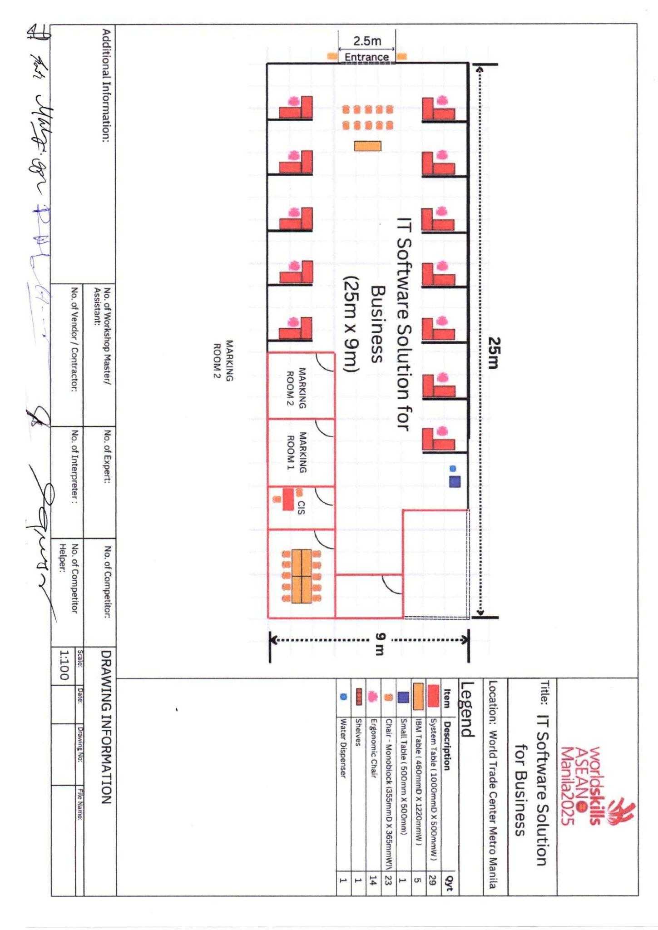

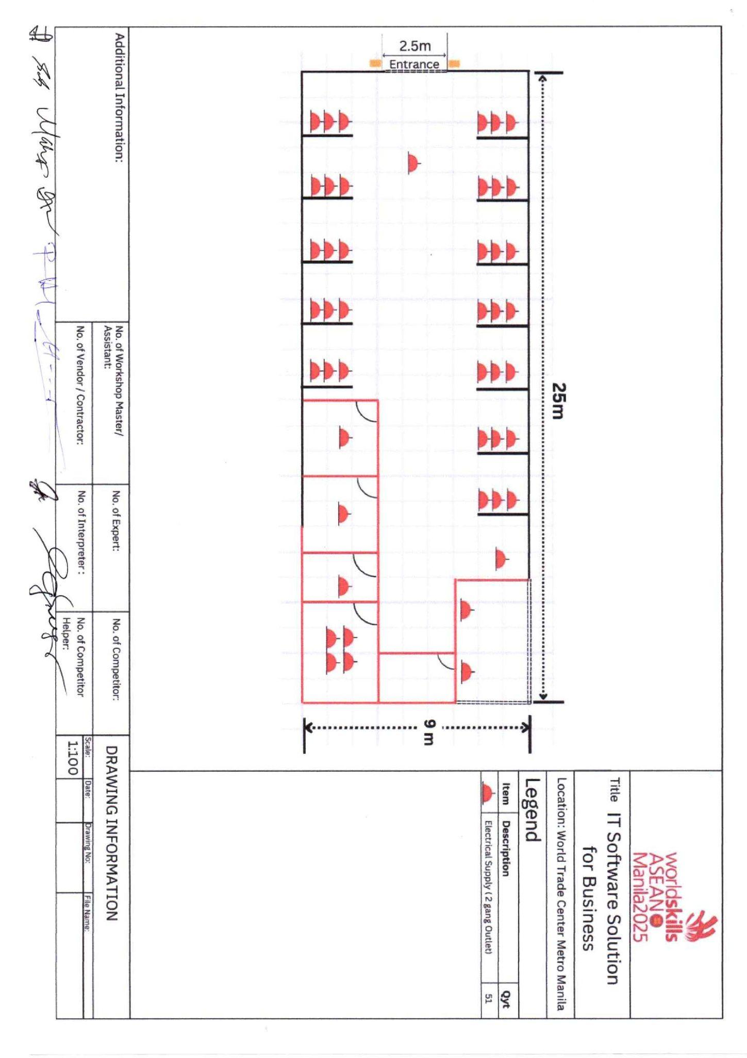

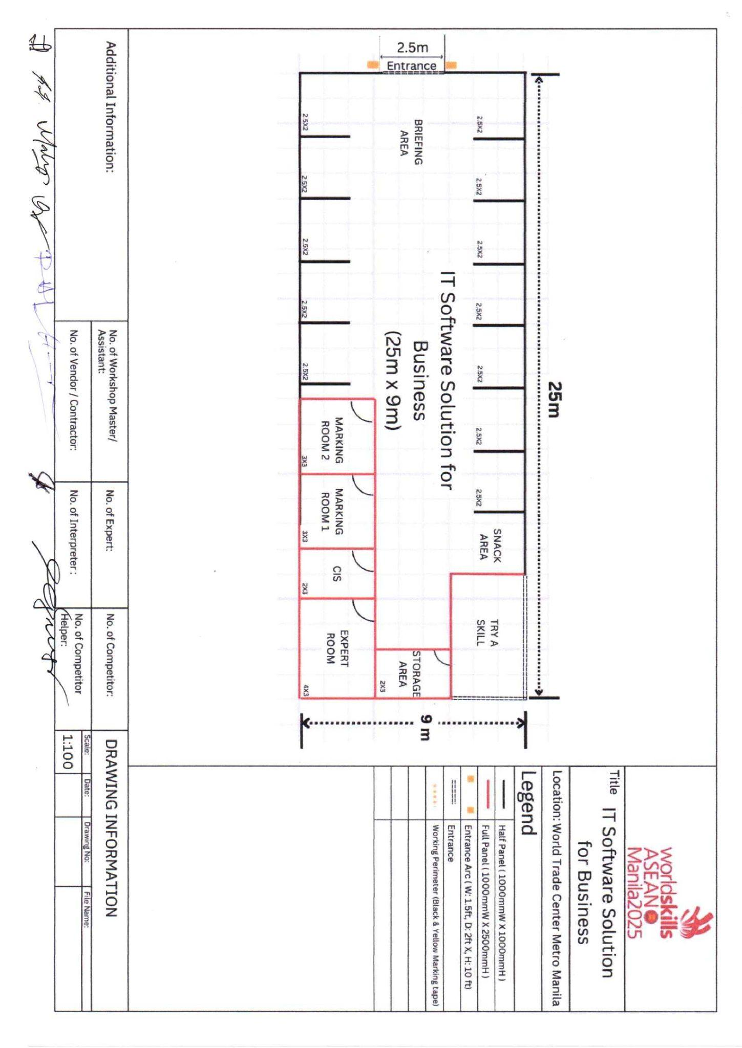

Annex E. Infrastructure List

No | Item | Category | Qty | Unit | Technical Specifications | Priority | Source | Company (if sponsored) | Picture/Link
1 | Competitor Desktop | Equipment & Tools | 12 | units | HP Z4 G4 W-2145 / RAM 32GB DDR4 / SSD 512GB + HDD 1TB / GPU P620 | High | Pending
2 | FHD Monitor (+ HDMI cable) | Equipment & Tools | 24 | units | Samsung - S33GC | High | Pending
3 | Keyboard (QWERTY) | Equipment & Tools | 12 | units | DK123 or equivalent | High | Pending
4 | Mouse | Equipment & Tools | 12 | units | Wired Mouse | High | Pending
5 | Cable HDMI | Equipment & Tools | 24 | units | CG525 | High | Pending
6 | UPS for workstation (1000W) | Equipment & Tools | 12 | units |  | High | Pending
7 | Mini DisplayPort - HDMI | Equipment & Tools | 12 | units |  | High | Pending
8 | Microsoft Visual Studio (with MAUI) | Equipment & Tools | 1 | unit | Community 2022 | High | Pending
9 | MAUI Emulator | Equipment & Tools | 1 | unit | Pixel 3 | High | Pending
10 | .NET Framework | Equipment & Tools | 1 | unit | v 4.8.1 | High | Pending
11 | .NET Core | Equipment & Tools | 1 | unit | v 8.0 | High | Pending
12 | Microsoft SQL Server | Equipment & Tools | 1 | unit | 2022 | High | Pending
13 | Eclipse | Equipment & Tools | 1 | unit | v 2022-12 (4.26.0) | High | Pending
14 | ASP.Net Framework | Equipment & Tools | 1 | unit | v 4.8.1 | High | Pending
15 | SQL Server Management | Equipment & Tools | 1 | unit | v 20 | High | Pending
16 | JDK | Equipment & Tools | 1 | unit | Latest Version | High | Pending
17 | MySQL | Equipment & Tools | 1 | unit | Latest Version | High | Pending
18 | Microsoft Office | Equipment & Tools | 1 | unit | Latest Version by the Host country | Medium | Pending
19 | Notepad++ | Equipment & Tools | 1 | unit | Latest Version | High | Pending
20 | Android （API）Kotlin and Java | Equipment & Tools | 1 | unit | Ladybug 2024.2.2 | High | Pending
21 | Android SDK & API | Equipment & Tools | 1 | unit | v 34 (Android 14) | High | Pending
22 | Android Compile SDK | Equipment & Tools | 1 | unit | v 34 (Android 14) | High | Pending
23 | Android Emulator | Equipment & Tools | 1 | unit | Pixel 6 | High | Pending
24 | Filezilla Client for windows | Equipment & Tools | 1 | unit | Latest Version | High | Pending
25 | VMWare Workstation | Equipment & Tools | 2 | units | Latest Version (30days free trial) | High | Pending
26 | Expert Laptop | Equipment & Tools | 1 | unit | Galaxy Book4 (i5, 8 GB RAM, 256 GB SSD) | High | Pending
27 | Projector | Equipment & Tools | 1 | unit | 3400 Lm LCD WXGA, 1280 x 800 16:10 Lamp | High | Pending
28 | Expert Desktop | Equipment & Tools | 2 | units | HP Z4 G4 W-2145 / RAM 32GB DDR4 / SSD | High | Pending
29 | FHD Monitor(+HDMI Monitor) | Equipment & Tools | 2 | units | S33GC | High | Pending
30 | Keyboard (QWERTY) | Equipment & Tools | 2 | units | DK123 or equivalent | High | Pending
31 | Mouse | Equipment & Tools | 2 | units | Wired mouse | High | Pending
32 | Cable HDMI (10 m) | Equipment & Tools | 2 | units | CG525 | High | Pending
33 | UPS (500w) | Equipment & Tools | 2 | units | UPS 500 W | High | Pending
34 | Cable tester (RJ 45) | Equipment & Tools | 1 | unit | TESTEUR DE CABLAGE RJ45 ET RJ12 | Medium | Pending
35 | Toolbox/ToolKit | Equipment & Tools | 1 | unit | FAT MAX | Medium | Pending
36 | U-UTP Cat.5e | Equipment & Tools | 1 | box | TUM404EGY | Medium | Pending
37 | RJ-45 connector cover | Equipment & Tools | 30 | pcs | RJ-45 connector cover | Medium | Pending
38 | Plastic cable coupler (2.5 mm) | Equipment & Tools | 30 | pcs | 500/pcs | Medium | Pending
39 | Network Router | Equipment & Tools | 2 | pcs | F100-C-G3 | Medium | Pending
40 | Server Cabinet (42U) | Equipment & Tools | 3 | pcs |  | Medium | Pending
41 | RJ45 Module Plug Cat5e | Equipment & Tools | 30 | pcs | D1551 | Medium | Pending
42 | Sound System with Microphone | Equipment & Tools | 1 | unit |  | Medium | Pending
43 | Digital Clock | Equipment & Tools | 1 | pc |  | Low | Pending

Annex F. Test Project
No | Module | Duration (hrs) | Weights (%)
1 | Session 1 - Mobile | 3.5 | 22
2 | Session 2 - Desktop | 2 | 12
3 | Session 3 - Mobile | 3.5 | 22
4 | Session 4 - Desktop | 3.5 | 22
5 | Session 5 - Desktop | 3.5 | 22
 | Total competition duration & weights | 16 | 100

Annex G. Competition Timetable

Legend
Reporting time
Familiarization/Competition time
Lunch time
Fun Programming Session (Not Marked)

C-2: Familiarization Session
07:00 |  | 08:00 |  | 09:00 |  | 10:00 |  | 11:00 |  | 12:00 |  | 13:00 |  | 14:00 |  | 15:00 |  | 16:00 |  | 17:00 |  | 18:00
C-1: Familiarization Session
07:00 |  | 08:00 |  | 09:00 |  | 10:00 |  | 11:00 |  | 12:00 |  | 13:00 |  | 14:00 |  | 15:00 |  | 16:00 |  | 17:00 |  | 18:00

Legend
Reporting time
Familiarization/Competition time
Lunch time
Fun Programming Session (Not Marked)

C1: Competition Session
07:00 |  | 08:00 |  | 09:00 |  | 10:00 |  | 11:00 |  | 12:00 |  | 13:00 |  | 14:00 |  | 15:00 |  | 16:00 |  | 17:00 |  | 18:00

C2: Competition Session
07:00 |  | 08:00 |  | 09:00 |  | 10:00 |  | 11:00 |  | 12:00 |  | 13:00 |  | 14:00 |  | 15:00 |  | 16:00 |  | 17:00 |  | 18:00

C3: Competition Session
07:00 |  | 08:00 |  | 09:00 |  | 10:00 |  | 11:00 |  | 12:00 |  | 13:00 |  | 14:00 |  | 15:00 |  | 16:00 |  | 17:00 |  | 18:00

Annex H. Marking Scheme - Measurement & Judgement

# | Subject | No. of Aspects | Marks | Percentage
1 | Measurement | 118-190 | 100 | 100
2 | Judgement | 0 | 0 | 0
 | Total | 118-190 | 100 | 100

